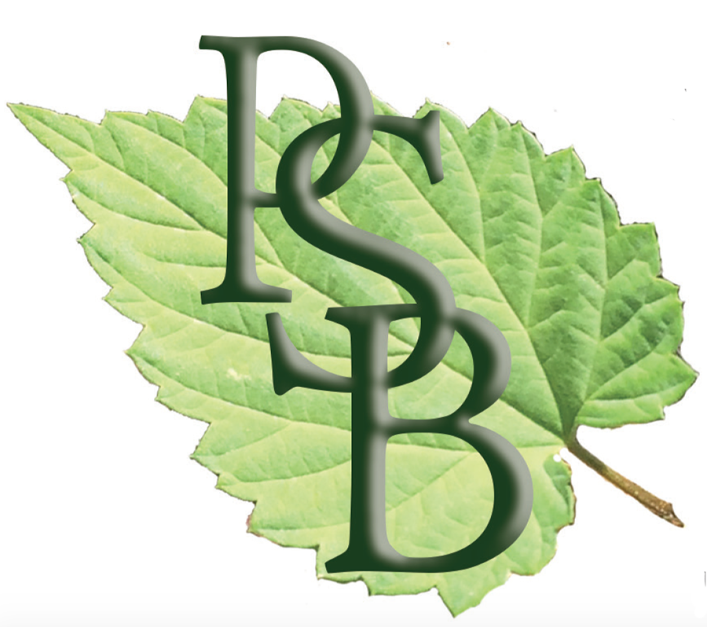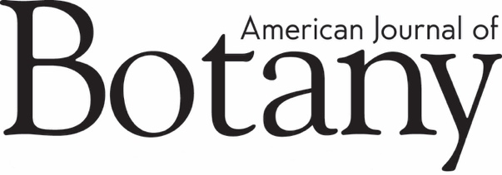

**Publications Report for the BSA Board Meeting**

**November 22, 2021**

**_______________________**

This report updates progress for BSA publications since this summer’s Botany meeting in July.

Open Access has gained momentum since [Plan S](https://www.coalition-s.org/) was launched in September 2018, and has accelerated during the pandemic. The problem for Society publishers is how to adapt, since publications have traditionally funded the activities of the Society to a large extent. We discussed this in the previous Board meeting, but it may bear repeating that Wiley is positioning itself as a major “player” in the OA space. Over the past year, they have acquired a large OA publisher, **Hindawi**; see a blog post and links in the [Scholarly Kitchen from January 2021](https://scholarlykitchen.sspnet.org/2021/01/11/wiley-acquires-hindawi-interview/)); an editorial management company (**J&J Editorial**; see this post about the acquisition, [SK October 2021](https://scholarlykitchen.sspnet.org/2021/01/11/wiley-acquires-hindawi-interview/)); negotiated several transitional deals (<https://www.wiley.com/network/researchers/licensing-and-open-access/transitional-agreements-for-authors-explained>); and are encouraging their Society partners to transition to OA (refer to their proposal and contract offer). They are asking BSA: Can we publish substantially more papers from authors who can pay to publish (through [APCs](https://en.wikipedia.org/wiki/Article_processing_charge) from funders or institutions or through Wiley’s transitional deals)?

A few questions in the larger community is: How is this equitable? (It’s not.) How can we make it equitable? Essentially, how can scholarship be made free to read and free (for authors) to publish?

Librarians are asking: Are publishers trying to replace their Big Deals with Transitional Deals, so essentially the budget outlay for libraries remains the same? How can we help our researchers navigate the many OA (and other) options?

The transition is going to be an interesting and bumpy ride.

**Consultation with Clarke & Esposito re: Wiley contract**

Heather and Amy worked with the consulting firm Clarke & Esposito to review the proposal and contract renewal from Wiley. We determined this was necessary because of the dramatic changes in publishing over the past 5 years and because of the very different terms Wiley is proposing in the new contract. Our revenues are expected to reduce quite dramatically and become more undpredictable in the next 5+ years; Wiley is positioning itself to take less of a hit during this transition (i.e., they don’t want to lose money on us).

A couple of the takeaways—we *will* need to increase APC rates (ours are low in comparison to similar journals); and we’ll need to publish a **lot** more (how is that going to happen, you ask? We are asking that, too!).

We contacted Wiley with an initial response to the contract, requesting reconsideration of financial details; a meeting to discuss this is scheduled for the week of November 15.

We have until the end of the year to determine whether we will give notice that we plan to explore other potential publishing partners. We’ve already stated we don’t want to do this, but it can’t be off the table.

**Call for EiC applications for *APPS***

After more than 10 years of service to the journal, Theresa Culley (University of Cincinnati), who helped to launch *APPS* in 2013 as its first Editor-in-Chief, will be stepping down. Under her guidance, the international readership and authorship of the journal have grown, and its impact factor has steadily increased. We are recruiting for a new Editor-in-Chief, and the deadline for applications is November 12, 2021. The members on the ad hoc search committee are: Emily Sessa (chair); Joyce Chery, Norm Wickett, Mike Moore, Pam Soltis, Karolina Heyduk, Amy McPherson, and Beth Parada. To find out more, [click here](https://botany.us2.list-manage.com/track/click?u=7b5241ec2a609d26192947333&id=822129105d&e=4b94e039f7).

**New Reviews Editor for *AJB***

We launched our Reviews series in *AJB* in 2019, following a Wiley-BSA strategy meeting in Chicago (and much discussion prior to that). To date, we have published 8 Reviews and have several others in the works. Jannice Friedman (Queens University) led the effort to set the guidelines and recruit authors through September 2021—we are grateful for her tremendous contributions. This fall, we sent out a call for applications for a new Reviews Editor. Among several impressive candidates, Kasey Barton (University of Hawaiʻi at Mānoa) was chosen to serve a 2-year term beginning October 1, 2021.

**New *AJB* Synthesis Prize**

At the 2018 Board meeting, a motion put forward by Sean Graham (then Director-at-Large for Publications) was approved: **MOTION** that we initiate a monetary and prestigious prize for high-profile review papers that would be open to scientists in the first five years since receiving their PhD **–> APPROVED**

An ad hoc committee (Sean Graham, Pamela Diggle, Kasey Barton, Emily Sessa, and Amy McPherson) is working to develop the prize (and a name for the prize). The definition of “early-career” is post-docs or equivalent within 6 years of receiving their PhD. EC researchers will be invited to submit proposals; a committee will determine which applicants to invite to submit a manuscript; all *Synthesis* papers published in a calendar year will be considered for the Prize.

***Action Item for the Board*:** Sean’s original motion was for a $2K competitive early-career publication medal/prize for AJB, but it’s not clear the amount was officially approved. I request that the Board consider and approve **$2K** for this prize.

**New Recruiting Editor for *APPS***

We are also pleased to announce the new Recruiting Editor for *Applications in Plant Sciences*, [**Tatiana Arias**](https://botany.us2.list-manage.com/track/click?u=7b5241ec2a609d26192947333&id=245e752910&e=4b94e039f7) (Marie Selby Botanical Gardens). In this new role for *APPS*, she will work with the Editor-in-Chief over a 2-year term to identify and invite potential new authors to contribute their work and spearhead special issue development.

**New Journal Design**

In August, we transitioned both journals to Wiley’s New Journal Design—a more structured PDF page layout that simplifies (and speeds up) production. In addition to changing our page design, the journals moved to a new production team in India, which has resulted in improved turnaround times.

**Accepted articles being posted online for *AJB***

Beginning in October 2021, *AJB* is giving authors the opportunity for us to post their Accepted Articles online. With the author's permission, we can publish the accepted paper as a PDF prior to copy-editing and typesetting. It is given a Digital Object Identifier (DOI), which allows it to be cited and tracked, and it will be indexed by PubMed. The paper will still be copy edited and the author will have an opportunity to respond to queries before the paper goes into proofs. The final copy-edited and proofed articles (i.e., the article versions of record) will appear in an issue; the link to the article in PubMed will automatically be updated.

**Change in publication schedule for *APPS***

*APPS* is making strides, and several special issues are in the works (see below), but regular manuscript submissions have slowed, essentially since Primer Notes were discontinued in late 2019. To accommodate fewer manuscripts in the pipeline, beginning in September *APPS* moved to a **bimonthly publication schedule**. Individual articles will continue to publish [online](https://botany.us2.list-manage.com/track/click?u=7b5241ec2a609d26192947333&id=516c0b81bc&e=4b94e039f7) as they are accepted and approved for publication.

**New Special issues in development**

*APPS* special issues in production for 2022:

* *Methodologies in Gametophyte Biology*—led by Sally Chambers, Jerald Pinson, and Susann Wicke
* *Advances, Applications, and Prospects in Aquatic Botany*—led by Julia Cherry and Greg Pec
* *Meeting the Challenge of Exceptional Plant Conservation: Technologies and Approaches*—led by Emily Coffey, Valerie Pence, and Megan Philpott

Special issues planned for 2023:

* *Low-Cost Methods 2* (working title)—led by Greg Pec and Gillian Dean
* *DNA/RNA extraction protocols*—led by Ed McAssey and Nora Mitchell
* *Imaging techniques*—led by Pam Soltis and Gil Nelson

*AJB* special issue for 2022:

* *Approaches to the Study of Quantitative Fitness-Related Traits*—led by Susan Mazer, Eugenio Larios, Ann Sakai, and Stephen Weller

Potential joint special issue for 2023:

* *Pollen as the Link Between Phenotype and Fitness*—led by Agnes Dellinger, Vini de Brito, Nathan Muchhala, Oystein Opedal, and Rocio Perez-Barrales

**Transition in our freelance *AJB* Content/Assistant Editor** **position**

Marian Chau, who has worked in this role since October 2019 is stepping down, and we will be recruiting a new person. The Editor checks papers that are tentatively accepted to make sure they adhere to our final requirements before they are officially accepted and sent to production; edits author "highlights"; and fills in with routine tasks (checking in original MSS, assigning out revised MSS, sending routine reminders, etc.) when the managing editor is away from the office for extended periods.

***AJB* Changes to the Editorial Board post-meeting:**

**New** **Associate Editors**: Julieta Rosell (UNAM, Mexico), Hanno Schaefer (Technical University of of Munich, Germany), and Jennifer Tate (Massey University, New Zealand).

**Retiring Associate Editors**: R. Geeta and Mark Ooi.

NoChanges to the *APPS* Editorial Board post-meeting.

**BSA Early Career Advisory Board**: The inaugural group was established in November 2019. We are recruiting for a new board now.

**Manuscript submissions:**

For *AJB*, manuscript submissions are down 18% over where we were last year at this time.

For *APPS*, submissions are the same as they were last year at this time.

NOTE: We expected submissions would decrease when we stopped accepting Primer Notes in *APPS*; we also anticipate a higher Impact Factor in the future because of this. However, low submission numbers are a concern for both journals. There is a lot of competition for papers, and we need our community to support its society journals!

***Plant Science Bulletin***

The *Plant Science Bulletin*, entering its 68th volume as the voice of the Society, continues to share news of interest to BSA members (and beyond). Recent issues have focused on DEI issues, plant awareness disparity, and much more! The most recent issue can be found at <https://botany.org/home/publications/plant-science-bulletin.html>.

**The BSA has recruited a new Student Social Media Liaison:** [Teressa Alexander](https://botany.org/home/careers-jobs/careers-in-botany/bsa-spotlight-series/teressa-alexander.html) (University of the West Indies, Trinidad) will help enhance the BSA’s social media reach—and will help amplify the authors and their work published in BSA journals.

Respectfully submitted,

Amy McPherson

8 November 2021